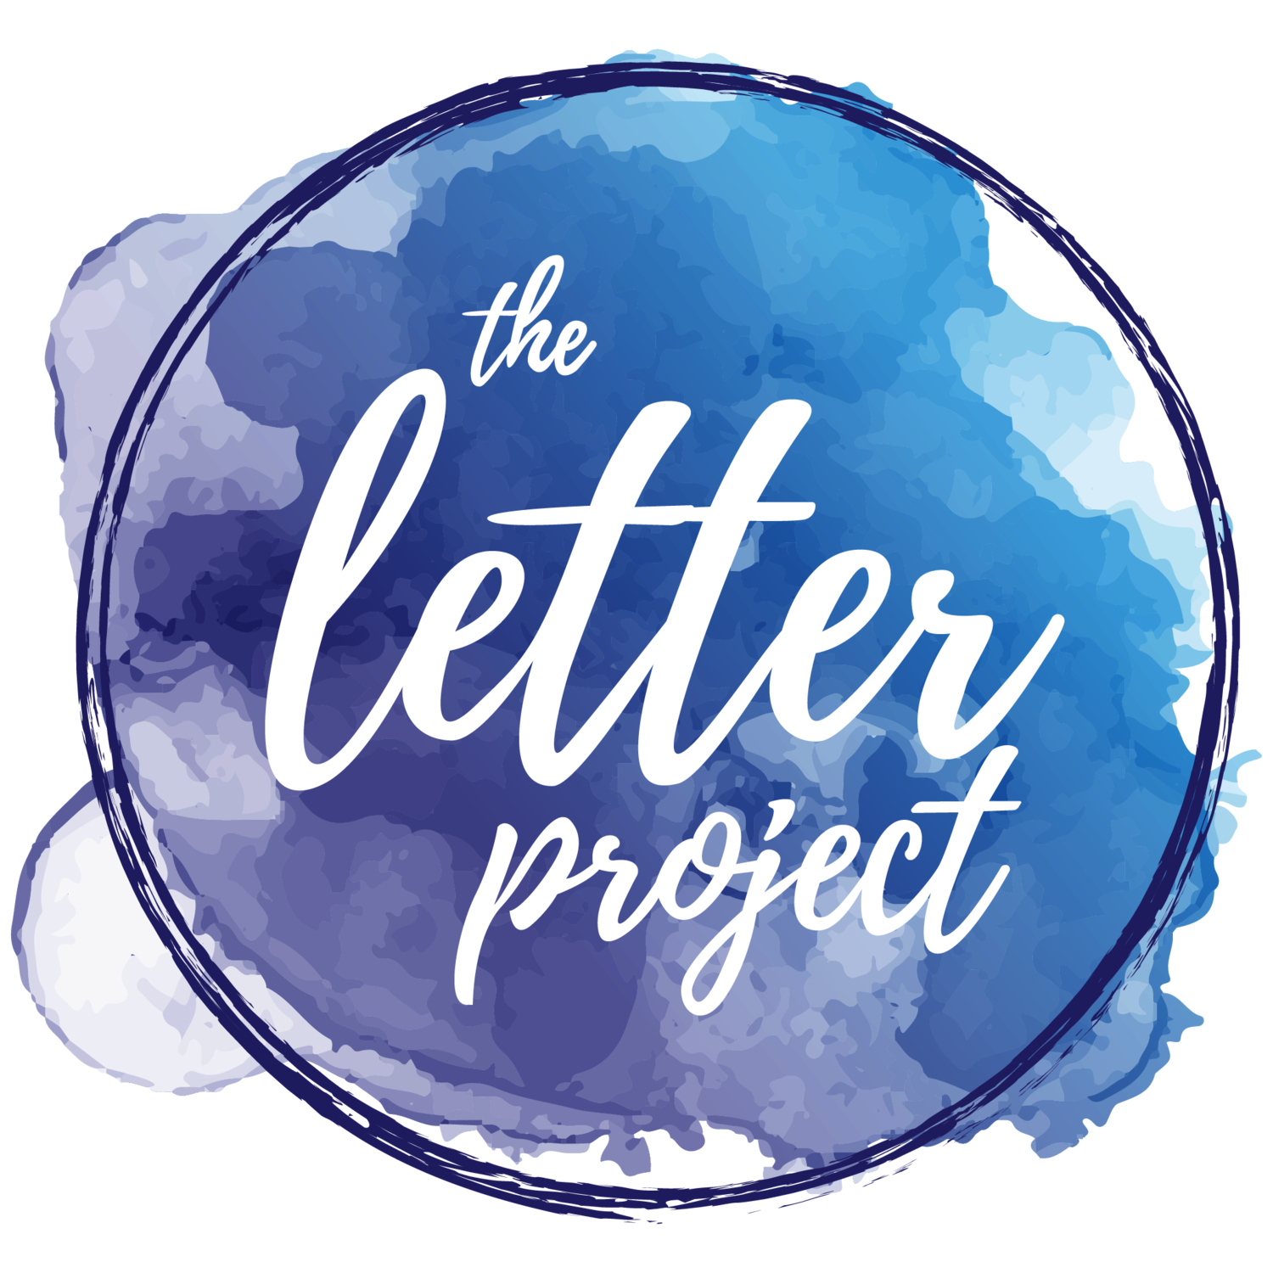

Kendall Aronson

Letter Project Fact Sheet - Write Nights

**What is it?**

Write Nights are events hosted by our Letter Writers or organizations that allow a group of ladies to get together and all write letters to girls in need of support. It can be a great activity to do with a club, a yoga group, a sports team or even some friends gathering at a house. After the Write Night is done, you can send us all the letters you create. We will bundle them up for the girl and send them their happy mail after you return it

**How do you sign up?**

The link below will take you to the form to sign up. We ask for your name, email and some information about the event itself and the participants so we can pair you with Letter Requests that can fit best with the ages of the writers. After Letter Writers sign up, we will get back to them within the next two business days with their requests.

Link for sign up: <https://www.toloveourselves.com/host-a-write-night/>

**What do the writers need to provide?**

The hosts of the Write Night can provide paper, pens and/or markers as well as food if they would like. We will provide the letter requests. If participants would like to they can also bring along donations for the Letter Project.

**What materials should we use?**

Make sure to have writing utensils and something to write letters on! Construction paper, stationary, colored paper, printer paper or even notebook paper: you can use many things to write your letters! We recommend not using index cards, but otherwise the options are endless. From markers to paint to sharpies to pencils, any writing utensils are fine as well. You are also free to decorate your letters with stickers, washi tape and anything else if you wish, but if you don’t want to decorate your letters that’s fine too. Please do not type your letters, handwritten is much more meaningful.

**How do we know what to write?**

When we send you the letter requests, we will also send you a quick sheet giving basic information for what types of things you can include and suggestions on letter writing. If you sign up to be a letter writer through our website, you can also access other sample letters on the writers portal.

**Do we need to put the letters in envelopes?**

Once we receive your letters we check through them for content and then bundle them up and put them all in one large envelope. Because of this, the recipient will not recieve the envelope you send the Letter Project. If you would like the recipient to also have an envelope, don’t seal it. If you then put the unsealed envelope in a larger envelope that is mailed to us, we can keep your letter in that unsealed envelope.

**Have any questions?**

Contact our Assistant Director Jess McLaughlin with any questions at [jess@toloveourselves.com](mailto:jess@toloveourselves.com)

Or contact us on Facebook or Instagram @toloveourselves