**Jessica “Jess” McLaughlin**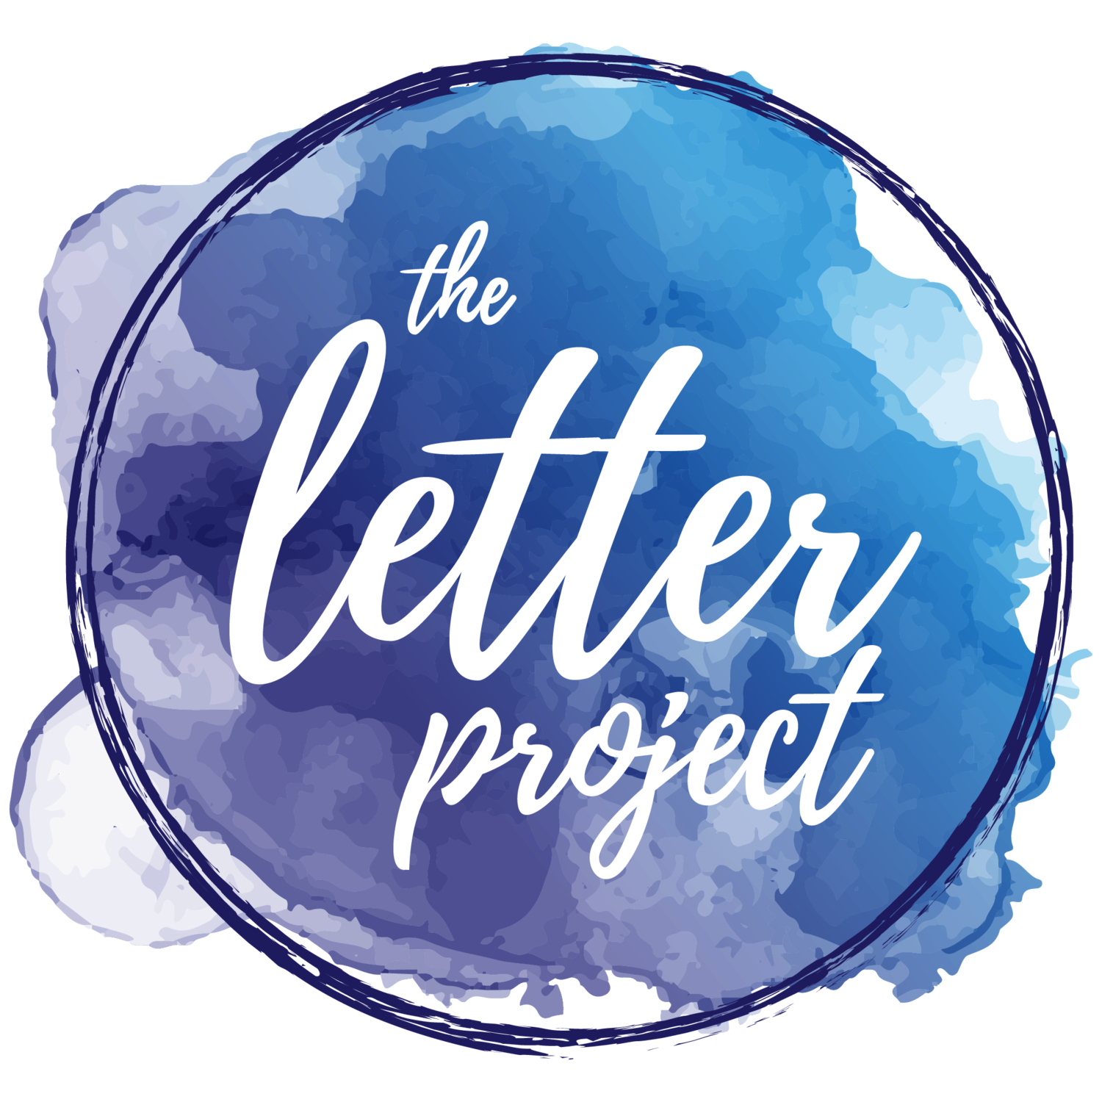

**Assistant Director of the Letter Project**

Jess became the assistant director of the Letter Project earlier this year. She manages letter writers, donors, weekly emails, fundraising and grant writing for the Letter Project in her new role. Prior to joining the Letter Project, she received a Bachelor of Arts degree from the University of Alabama, majoring in religious studies and minoring in psychology. She has also been a religious studies high school teacher, preschool teacher and realtor. She currently is also the Co-Director of Camp Maxwelton and Camp Lachlan, helping to encourage self growth in girls there. She also fundraised for nonprofits during her time in college. Before taking on the role as the assistant director, Jess was a Letter Writer for the Letter Project and she attended events for the International Day of the Girl hosted by the Letter Project.

Contact at [jess@toloveourselves.com](mailto:jess@toloveourselves.com)